ПОРТФОЛИО

фото
________________________________________________________________________________________________________________________________________________
Учени__ класса

__________________________________________________________________________________________________________________________________________________________________________________________________________________________________________________________________________________
______________________________________________
Моё имя
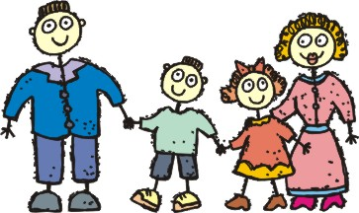
Моя семья
____________________________________________________________________________________________________________________________________________________________________________________________________________________________________________________________________________________________________________________________________________________________________________________________________________________________________________________________________________

Мои увлечения

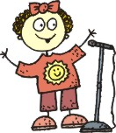
________________________________
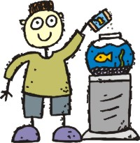
_______________________________________________________________________________________________________________________________________________________________________________________________________________________________________________________________________________________________________________________________________________________________________________________________________________________________________________________________________________________________________________________________________________________________________________________________________________________________________________________________________________________________________________________________________________________________________________________

Мои друзья

________________________________________________________________________________________________________________________________________________________________________________________________________________________________________________________________________________________________________________________________________________________________________________________________________________________________________________________________________________________________________________________________________________________________________________________________________________________________________________________________________________________________________________________________________________________________________________________________________________________________________________________________________________________________

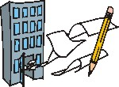 __________________________________________________________________________________________________________________________________________________________________________________________________________________________________________________________________________________________________________________________________
Моя школа
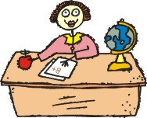
Мои учителя
______________________________________________________________________________________________________________________________________________________________________________________________________________________________________________________________________________________________________________________________________________________________________________________________________________________________

МОЯ
УЧЁБА


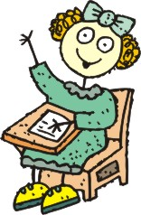

МОЁ
ТВОРЧЕСТВО

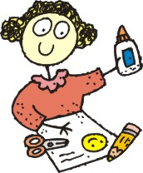
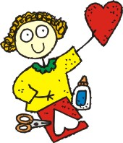

МОИ
ДОСТИЖЕНИЯ

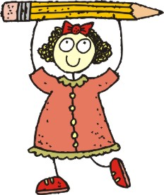

РАБОТЫ,
которыми
я горжусь
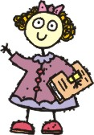
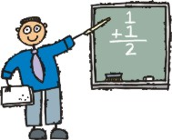

МОИ
ВПЕЧАТЛЕНИЯ



ОТЗЫВЫ И
ПОЖЕЛАНИЯ



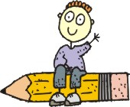

МОЯ
ОБЩЕСТВЕННАЯ
РАБОТА
